Biology IB 11.
Circulatory and nervous system home exam.
Name:
Write also your name as the name of the file you submit.
No exam will be accepted that is not in proper .pdf format.

1. Draw a human heart and label chambers, valves and major vessels. [5]
(Recommended to draw in paper, take a picture and paste it)

2. State three differences between veins and arteries [1 each]

3. Briefly describe the functions of the lymphatic system. [2] [1 bonus]

4. Explain briefly how blood moves up along the legs even though the heart doesn't "suck it up". [2]

5. What is the name of the build-up of matter in the arteries and where is it particularly dangerous? [2]

6. Label this diagram. [1 each]

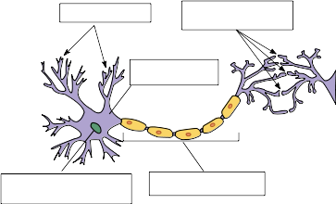

7. Explain the propagation of electrical impulses along a neuron including the role of myelin. [7]

8. Explain how a synapse works, including how the nerve impulse is transmitted through it and how it gets ready for the next impulse. [7]

9. This is a graph of the pressure in a ventricle and its associated atrium.
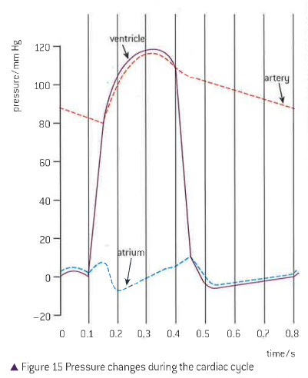

Which statement explains the changes in pressure?

A. The left atrium has low pressure during the cardiac cycle because very little blood flows into it.
B. The sinoatrial node stimulates the contraction of the aorta causing a pressure increase.
C. Pressure in the aorta increases when the semilunar valve opens and blood flows in from the left ventricle.
D. Epinephrine stimulates the relaxation of the left ventricle, decreasing the pressure.

10. What process is blocked by neonicotinoid pesticides in insects?

A. Transmission of the nerve impulse in the presynaptic neuron
B. Formation of the synaptic vesicles
C. Release of the neurotransmitter
D. Binding of neurotransmitters to postsynaptic acetylcholine receptors

11. How does potassium move across the membrane of a neuron during repolarization?

A. Simple diffusion
B. Facilitated diffusion
C. Endocytosis
D. Active transport

12. What is a feature of the left atrium?

A. Epinephrine decreases its rate of contraction.
B. It contracts as the left ventricle contracts.
C. It receives blood from the left pulmonary artery.
D. Its pressure decreases as the left ventricle fills up.

13. If schizophrenia is caused by an overabundance of the neurotransmitters dopamine and serotonin in the synapses of some areas of the brain, which drug action could work in treating the
symptoms?

A. Release of cholinesterase into the synaptic cleft
B. Increased re-uptake of dopamine and serotonin by presynaptic neurons
C. Increased permeability of the presynaptic neuron to sodium
D. Blockage of dopamine and serotonin receptors on presynaptic neurons

14. What is the mechanism of sodium-potassium pumps in neurons that generates a resting potential
by active transport?

A. K + from cytoplasm binds to the pump and stimulates its phosphorylation by ATP.
B. Phosphorylation of the pump causes its shape change in order to move Na + into the cytoplasm.
C. K + from inside the cell binds to the pump and causes the release of the phosphate group.
D. Na + from cytoplasm binds to the pump and stimulates its phosphorylation by ATP.

15. Outline two factors that increase the risk of coronary heart disease (CHD). [2]

16. Outline what fibrillation is and how a defibrillator is used to treat it. [3] [1 bonus]

17. (HL question) Outline the role of the sinoatrial node in the contraction of the heart [2]

18. The graph below shows an electrocardiogram (ECG) trace.
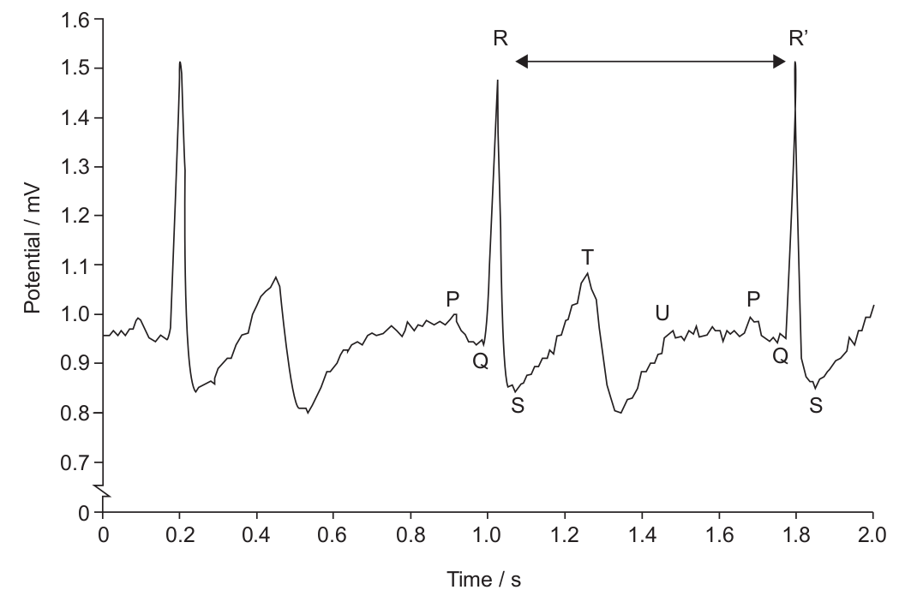
a) Using the letters provided, identify the parts where the ventricle muscles are contracting [1]

b) What does the T wave indicate? [1]

c) What would the time between R and R' represent? [1]

